Install Google Play services from SDK Manager

Import it to the eclipse workspace

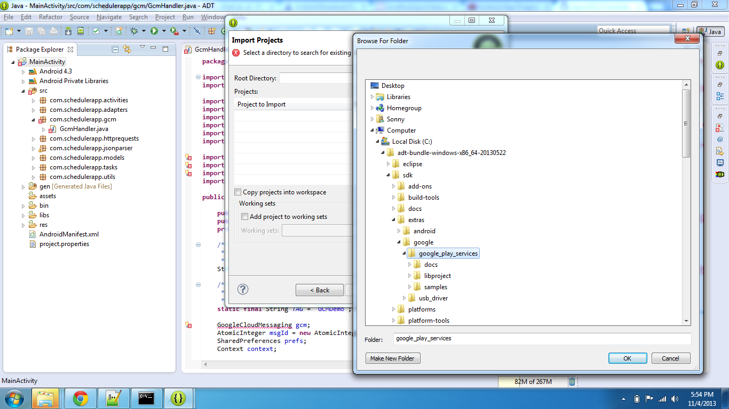

Click Import project into workspace, Finish

Go to properties of SchedulerApp. Click Android and Add Library, Select the google_play_services_lib project, click Apply

